**Lines and Angles**

# Introduction to line and the terms related to it

* + A **line** is a breadthless length which has no end point. Here, AB is a line and it is denoted by AB.

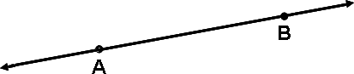

* + A **line segment** is a part of a line which has two end points. Here, AB is a line segment and it is denoted by AB.

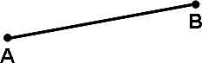

* + A **ray** is a part of a line which has only one end point. Here, AB is a ray and it is denoted by AB.

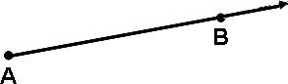

# Collinear/Non-collinear points

* + Three or more points which lie on the same line are called **collinear points**.
  + Three or more points which do not lie on a straight line are called **non-collinear points**.

# Introduction to Angle

* + An **angle** is formed when two rays originate from the same end point.
  + The rays making an angle are called the **arms** of the angle.
  + 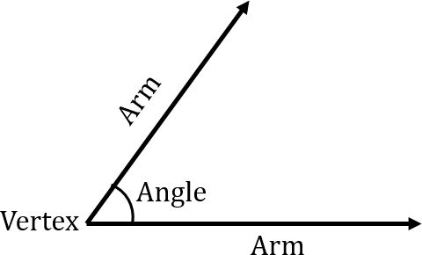The end point from where the two rays originate to form an angle is called the **vertex** of the angle.

# Types of angles:

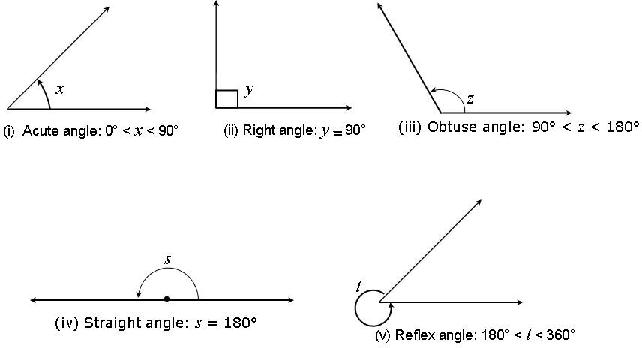

1. **Pair of Angles**
   * Two angles whose sum is 90° are called **complementary angles.**
   * Two angles whose sum is 180° are called **supplementary angles.**

# Intersecting and non-intersecting lines

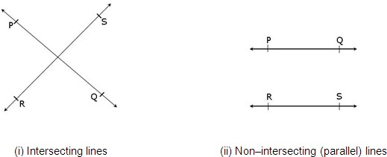

1. **Adjacent angles**

Two angles are **adjacent**, if they have a common vertex, a common arm and their non–common arms are on different sides of the common arm.

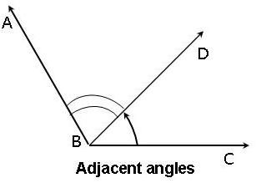

In the figure, *ABD* and *DBC* are adjacent angles.

# Linear pair of angles

If a ray stands on a line, then the sum of the two adjacent angles so formed is 180° and vice-versa. This property is called as the **linear pair axiom** and the angles are called **linear pair of angles**.

In the figure, *ABD* and *DBC* are linear pair of angles i.e. *ABD* + *DBC* = 180o.

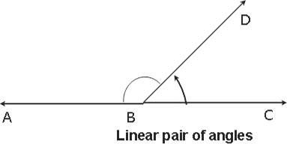

If the sum of two adjacent angles is 180°, then the non-common arms of the angles form a line.

# Vertically opposite angles

* + The **vertically opposite angles** formed when two lines intersect each other.
  + There are two pairs of vertically opposite angles in the given figure and they are *AOD* and

*BOC*, *AOC* and *BOD*.

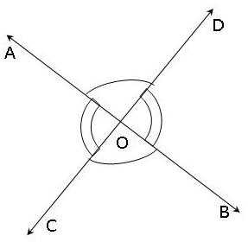

* + If two lines intersect each other, then the **vertically opposite angles are equal**.

# Transversal

A line which intersects two or more lines at distinct points is called a **transversal**.

# Pair of angles when a transversal intersects two lines

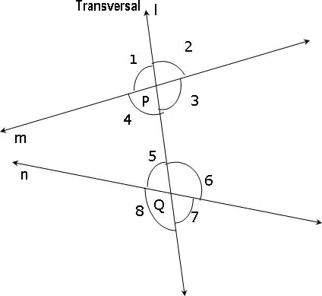

* + **Corresponding angles:**

1.  1 and  5
2.  2 and  6
3.  4 and  8
4.  3 and  7

# Alternate interior angles:

1.  4 and  6
2.  3 and  5

# Alternate exterior angles:

1.  1 and  7
2.  2 and  8

# Interior angles on the same side of the transversal are referred as co-interior angles/ allied angles/ consecutive interior angles and they are:

1.  4 and  5
2.  3 and  6
3. If a transversal intersects two parallel lines, then
   * Each pair of **corresponding angles are equal**.
   * Each pair of **alternate interior angles are equal**.

# Each pair of interior angles on the same side of the transversal are supplementary.

1. If a transversal intersects two lines
   * Such that a pair of **corresponding angles** is equal, then the two **lines are parallel**.
   * Such that a pair of **alternate interior angles** is equal, then the two **lines are parallel**.
   * Such that a pair of **interior angles** on the same side of the transversal is supplementary, then the two **lines are parallel**.
   * Such that the bisectors of a pair of **corresponding angles** are parallel, then the two **lines are parallel**.

# Lines parallel to the same line

Two lines which are parallel to the same line are parallel to each other. This holds for more than two lines also i.e. if two or more lines are parallel to the same line then they will be parallel to each other.

# Angle sum property of a triangle

* + The sum of the angles of a triangle is 180°. This is known as the **angle sum property of a triangle**.

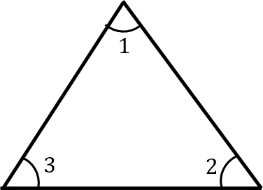

Here,  1 +  2 +  3 = 180o.

* + If a side of a triangle is produced, then the exterior angle so formed is equal to the sum of the two interior opposite angles. This is known as the **exterior angle property of a triangle**.

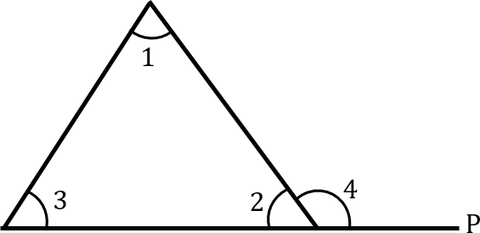

Here,  4 =  1 +  3.

* + An exterior angle of a triangle is greater than either of its interior opposite angles. In the above figure,  4 >  1 and  4 >  3.